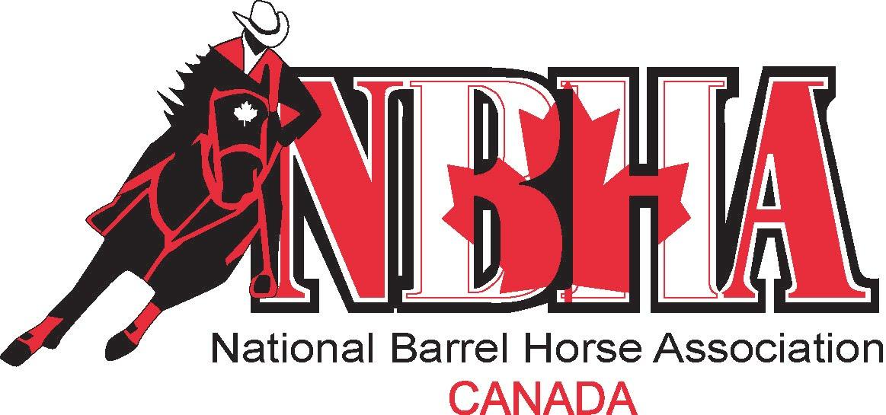
NBHA District 4 World Qualifiers 2016

OPEN
1D | 2D | 3D | 4D | 5D
Shelley Stephenson | Jodi Burgess | Amy Newman | Katie Aitken | Don Miller
Leslie Richards | Steve Storms | Katie Aitken | Don Miller | Karen Aitken
Jessica Richards | Leslie Richards | Leah Way | Murray Whiticar | Murray Whiticar
Jamie Burgess | Hayleigh Murray MacDonald | Megan Desjardins | Ella Sherwood | Katie Aitken
Katie Aitken | Jessica Tyner | Don Miller | Allan Burgess | Leah Way
Sara Simpson | Amy Newman | Steve Storms | Amber Archibald | Brittney Grant
Tyler Aitken | Carole Lampron | Kathy Richards | Donna Whiticar | Amber Archibald
Amy Newman | Jamie Burgess | Ella Sherwood | Leah Way | Donna Whiticar
Carole Lampron | Kristin Hawley | Maurice Miller | Bailey Plumadore | Alysa Mowat
Amber Miller | Megan Desjardins | Eve Veldhuyzen | Leslie Richards | Becky Murphy

Senior
1D | 2D | 3D | 4D | 5D
Shelley Stephenson | Maurice Miller | Donna Whiticar | Murray Whiticar | Don Miller
Maurice Miller | Don Miller | Bobbie Burris | Don Miller | Janet VanLeyen
Luc Menard | Kathy Richards | Kathy Richards | Allan Burgess | Jeff Grant
Allan Burgess | Bobbie Burris | Glenn Thompson | Natalie wood | Marie Churchill
Don Miller | Donna Whiticar | Don Miller | Bobbie Burris | Murray Whiticar
 | Allan Burgess | Allan Burgess | Glenn Thompson | Kathy Richards
 | Luc Menard | Natalie Wood | Donna Whiticar | Donna Whiticar
 | Murray Whiticar | Murray Whiticar |  | Allan Burgess
 | Glenn Thompson |  |  | Luc Menard
 |  |  |  | Shelley Stephenson

Youth
1D | 2D | 3D | 4D | 5D
Ella Sherwood | Eve Veldhuyzen | Ella Sherwood | Jordan Bailey | Jordan Bailey
David Moore | Ella Sherwood | Eve Veldhuyzen | Ella Sherwood | Kierah Sherwood
Eve Veldhuyzen | Becky Murphy | Becky Murphy | David Moore | Becky Murphy
Becky Murphy | David Moore | Kierah Sherwood | Becky Murphy | Cody Hoppe
Kierah Sherwood |  | David Moore | Kierah Sherwood
 |  | Jordan Bailey

Teen
1D | 2D | 3D | 4D | 5D
Katie Aitken | Leah Way | Katie Aitken | Alysa Mowat | Katie Aitken
Amber Miller | Katie Aitken | Bailey Plumadore | Leah Way | Leah Way
Amy Newman | Bailey Plumadore | Morgan Murphy | Katie Aitken | Cierra Boniface
Hayleigh Murray MacDonald | Morgan Murphy | Megan Losee | Amy Newman | Patricia Prest Thomas
Lindsay Coulter | Amber Miller | Leah Way | Bailey Plumadore | Morgan Murphy
 | Jordyn Sexsmith | Lindsay Coulter | Megan Losee | Tamara Lake
 | Amy Newman | Amy Newman |  | Colby Burns-Shaw

